How to check and update the version of the graphic driver software on Windows.

1. Input ”Device Manager” in the search window from the Start button on Windows.

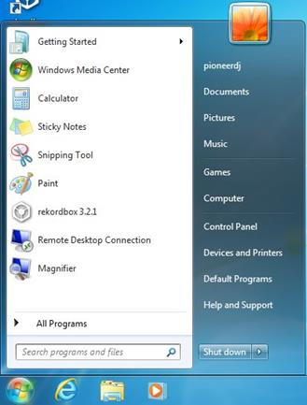

2. Launch Device Manager.

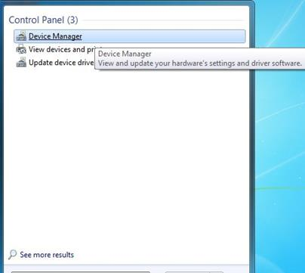

3. Search update to the driver and, if you find any, update the driver software.

Right click “Intel(R) HD Graphics” below the “Display adaptors” and select “Update Driver Software…” from the dropdown menu.

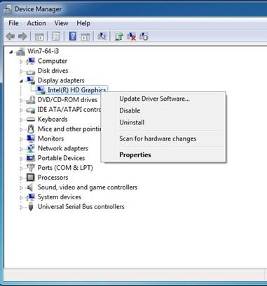

Select “Search automatically for updated driver software” in the popup window.

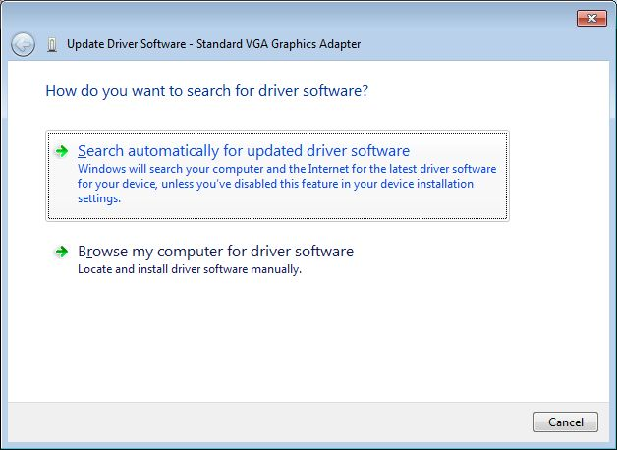

4. If the optimal driver software is already installed, the following window will appear.

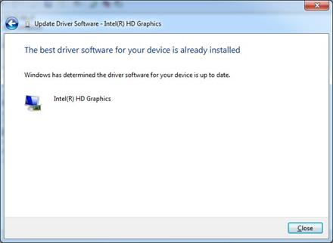

If the driver software is not updated, it will be automatically updated and the following window will appear.

